NEC Show Team
Looking to take your riding to the next level? Then join one of Nassau Equestrian Center’s Show Teams! NEC offers both a Junior and Senior Division, that will help riders make strides toward the show ring. Each lesson is geared to prepare students for both hunter and equitation classes, with an emphasis on etiquette and real life scenarios (i.e. practice shows) Talk to us about an evaluation lesson to see where you place today!
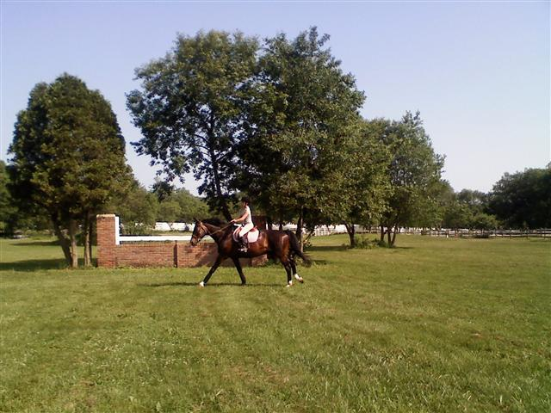
Senior Division

Interested in meeting riders your own age who share the same goals of hitting the show circuit? If that's the case, then you need to consider joining NEC's Senior Division of Show Team. Show Team is a weekly group lesson in which students will practice courses, perfect striding and timing, work on ring etiquette and so much more. Students improve their skills through practice, games and mock competitions; all of which will better prepare them for the circuit. Show Team requires a commitment from students, not only to themselves but to their team mates. Senior Division is a great stepping stone to competing in the Intercollegiate Horse Show Association once students are in college!
Open to Advanced WTC-Jump Riders
Riders should have already had some show experience
Riders should be comfortable riding in a group
Space is limited so sign up now!!
Senior Division Schedule
Date and time pending

Junior Division
Looking to meet other riders who are getting ready to begin competing? Junior Division Show Team is the perfect place to start. Junior Division is the perfect place for riders who have never shown before, as it begins to teach the etiquette and intricacies of hunter and equitation classes. Junior Division builds confidence through mock shows, games and competitions; all while becoming comfortable with riding in a group of horses (simulating a flat class). Student's will be able to form team atmosphere and embark on their first showing experience as a team. Junior Division is a great introduction to showing and a stepping stone to NEC's Senior Division.

Open to Intermediate WTC-Jump Riders
Group is geared to students with little or no show experience
Riders should be comfortable riding WTC in a group
Space is limited so sign up now!!
Junior Division Schedule
Dates and times Pending

